 |  | AWS Wine Evaluation Chart
 |  | Name: |  |  |  | Date:
 |  | Wine Host: |  |  |  | Theme:
 |  | House Host: |  |  |  | Theme:
 |  | See Reverse Side for Scoring Guidelines
Order | Wine |  |  | Price | Appearance  (3 Max) | Aroma/  Bouquet  (6 Max) | Taste/  Texture  (6 Max) | Aftertaste  (3 Max) | Overall  Impression  (2 Max) | Total  Score  (20 Max)
1
2
3
4
5
6
7

APPEARANCE |  |  | The American Wine Society (AWS) is a national, non-profit, consumer organization that is dedicated to educating its members about wine appreciation, wine making, and wine evaluation. The AWS is an independent organization with no commercial affiliation.  The AWS has over 140 chapters throughout the United States. Membership is open to any adult interested in wine—amateur, enthusiast, or professional.  For further information, contact: AMERICAN WINE SOCIETY  P. O. Box 889  Scranton, PA, 18501  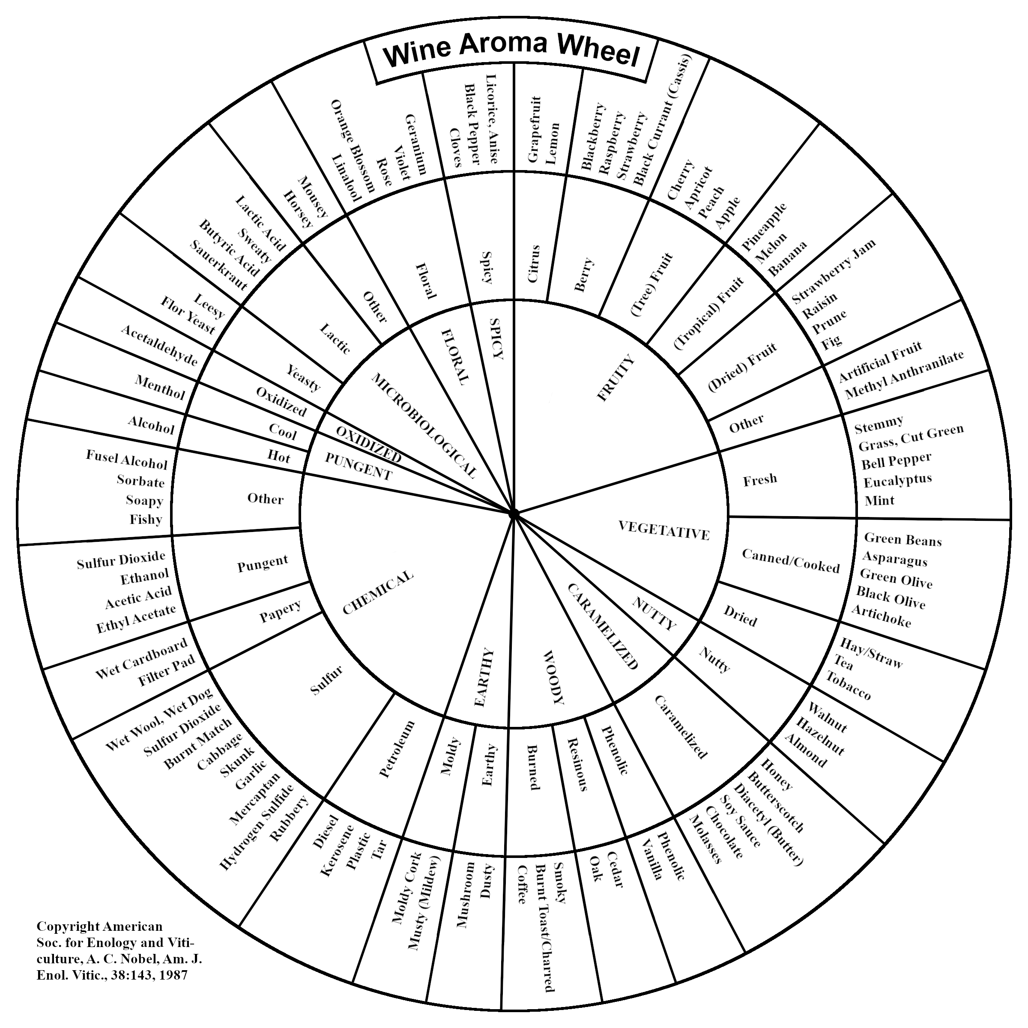
3 - Excellent | Brilliant, with outstanding characteristic color
2 - Good | Minor, unintentional haze and/or slight unexpected effervescence
1 - Poor | Substantial haze and/or unexpected effervescence
0 - Objectionable | Murky beyond reasonable expectation
AROMA and BOUQUET
6 - Extraordinary | Unmistakable, intense, remarkable, characteristic aroma of grape variety or wine style; outstanding, complex aroma and bouquet
5 - Excellent | Clean, characteristic aroma; complex aroma and bouquet
4 - Good | Clean, characteristic aroma; distinguishable aroma and bouquet
3 - Marginal | Clean, marginally characteristic, simple aroma and bouquet
2 - Deficient | Not clean, with slight off odors
1 - Poor | Not clean, with noticeable, identifiable fault
0 - Objectionable | Pronounced faulted aromas
TASTE and TEXTURE
6 - Extraordinary | Unmistakable, intense, characteristic flavors of grape variety or wine type; balanced; exceptionally complex flavors; impressive
5 - Excellent | Characteristic flavors; balanced; some measure of intensity and/or complexity
4 - Good | Characteristic flavors; balanced; somewhat lacking in intensity and/or complexity
3 - Marginal | Somewhat characteristic, but marginal in balance and/or intensity; simple
2 - Deficient | Lacking distinguishable flavors; weak, out-of-balance, thin, and/or off flavors
1 - Poor | Flawed; substantially out of balance; lacking identifiable flavors and/or texture
0 - Objectionable | Identifiably faulted; disagreeable flavors; not drinkable
AFTERTASTE
3 - Excellent | Long, lingering, complex aftertaste; impressive
2 - Good | Moderate, simple finish; typical for the style
1 - Poor | Short and/or not distinguishable aftertaste
0 - Objectionable | Unpleasant, disagreeable aftertaste
OVERALL IMPRESSION  2 Excellent  1 Good  0 Poor |  | TOTAL SCORES  8 – 20 Extraordinary  15 – 17 Excellent  12 – 14 Good  9 – 11 Marginal  6 – 8 Deficient

